Movies Database Application

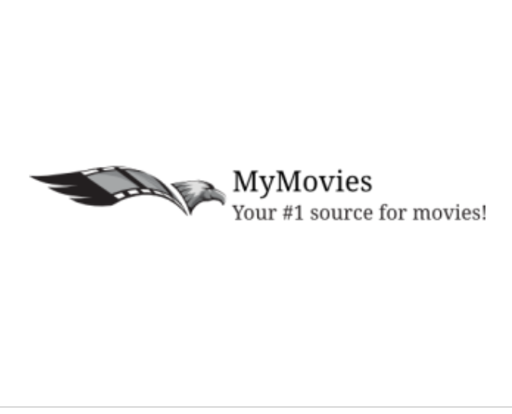

*May AlSalem*

Contents

Table of Figures 2

1 Introduction 3

2 My Approach 3

2.1 Planning and collecting 3

2.2 Analysis 3

2.3 Design 4

2.4 Implementation 4

2.5 Testing 5

3 App Functionalities 6

4 Conclusion 9

5 Assessment’s Listed Questions Answers 10

6 References 11

## Table of Figures

Figure 1: Design layout 3

Figure 2:Main app with the sort options 5

Figure 3: User see the latest movies. 6

Figure 4: Search for 'spider' movie in the database 7

Figure 5: Click the heart to add to favorites Figure 6: View of favorites list 7

Figure 7: Unclick the heart icon to remove from favorites. Figure 8: The previous movie was removed from the list 8

Figure 9: Display movie details. 8

Introduction

MyMovies application is a database for all the movies in one place which aims to help users discover latest movies, search by movie name, display movies details and add/remove favorites to favorites list using themoviedb.org. Personally, I’ve decided to go for a Mobile App using Android studio, JAVA due to couple of reasons which are that there is a great deal of available resources for android apps and the limited time that has been allocated for this assessment.

My Approach

## Planning and collecting

To start planning for Mymovies application, first I needed to learn more about the movie DB, how does it work and what do I need.

Then I started searching for available resources to decide on what technology should I go with in a quick and efficient way to develop the application within the period I have been assigned to. The decision has been made to developing it through Android as it turned out to be the most optimal option.

## Analysis

As the project requires several functionalities, I have searched for similar movie applications with similar functions that were also using themoviedb as a data source which led me to several applications in Github that mainly discovers Popular movies.

Afterwards, I have retrieved one of the Popular movies applications, which already had the movie display details and the favorites functionalities that I needed for this application that might save time.

So what I needed to do, is to configure the application and make it functional then add on the Latest sort, the Search functionalities and fix the issues.

The app required functionalities were as the following:

* As a user, I can see the latest movies.
* As a user, I can search movies.
* As a user, I can add a movie or remove it from my favorites.
* As a user, I can see movie details (Movie Name, Poster, Movie Description, Genres)

Which I have found the way for each functionality on the developers’ section in themoviedb website.

For the latest: get/movie/latest

For the search: get/search/movie

For the details: get/movie/{movie ID}

## Design

For the design, the application has very basic functionalities as it only had a toolbar, buttons, text field for the search and a grid for the movies list

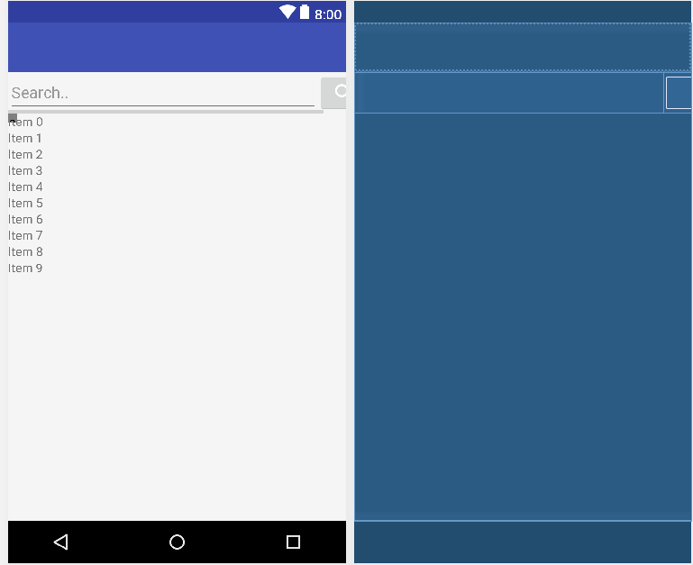

Figure 1: Design layout

## Implementation

For the implementation I have used one of the resources I have found on Github.

* First, I downloaded the application from Github and installed it.
* Once the installation was complete and the project has been imported, I have encountered a couple of issues with the application configuration and build.
* To fix above issue, I made a few changes to the code to fix the compilation issues and I have imported required packages.
* Next, I have replaced the API key with the one that I created.
* Then there was an issue with the display details function which were fixed by commenting the code lines for trailers and videos that I haven’t needed for the task.
* Now that the application is ready to operate, it’s time to add both the Latest and the Search functions into the application.
* For the latest function, first, I only replaced the popular strings with latest using get/movie/latest instead of popular, but it didn’t work as the latest function returns only one value not a list of items which is unlike the popular function.
* The other alternative I came up with to return a list of the latest movies was to use get/discover/movies with current date as a parameter then to sort it in a descending order.
* Following, I created a method for current date and converted it as string then sent it as parameter which worked.
* For the search
* Added a new UI component which are: Edit Text and Button.
* The button takes the text value and sends it back as a parameter using get/search/movies

## Testing

I have taken screenshots of the tested functionalities

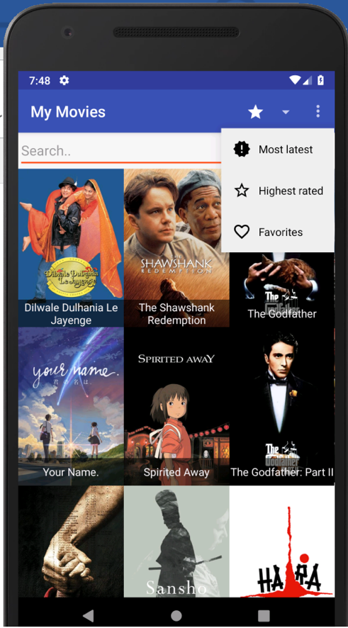

Figure 2:Main app with the sort options

App Functionalities

* User can see the latest movies.

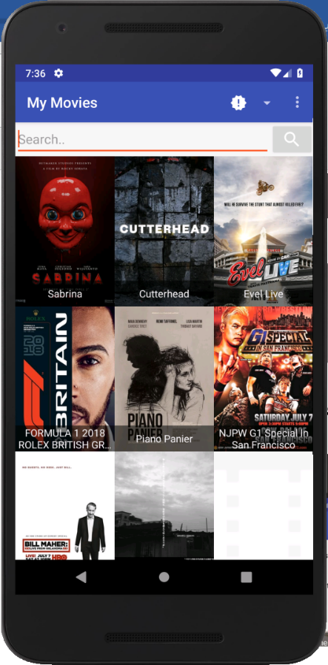

Figure 3: User see the latest movies.

* User, can search for movies.

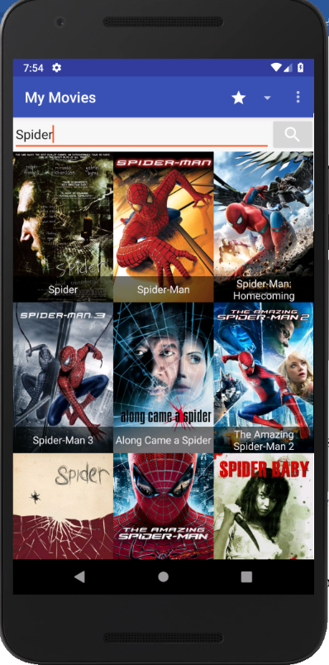

Figure 4: Search for 'spider' movie in the database

* User can add a movie or remove it from Favorites page.

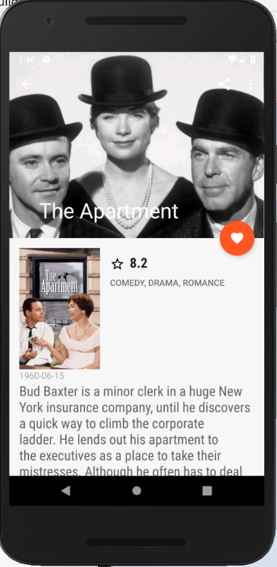 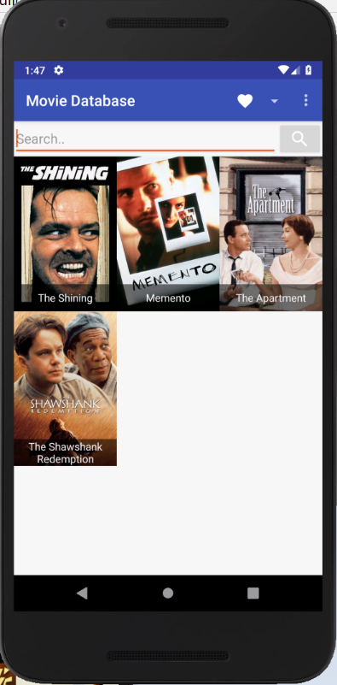

Figure 5: Click the heart to add to favorites Figure 6: View of favorites list

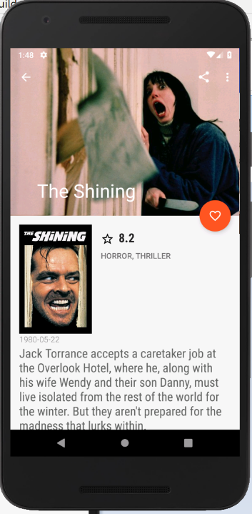 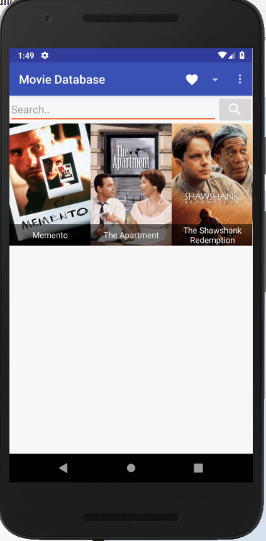

Figure 7: Unclick the heart icon to remove from favorites. Figure 8: The previous movie was removed from the list

* User can see movie details (Movie Name, Poster, Movie Description, Genres)

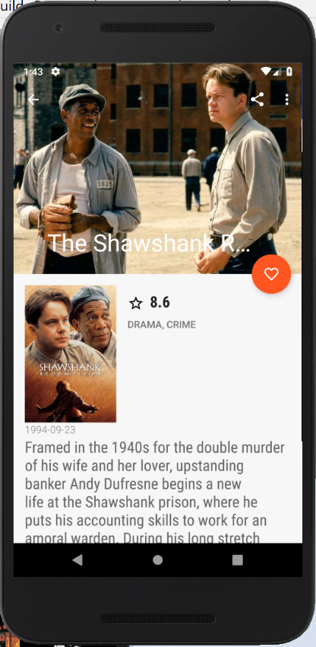

Figure 9: Display movie details.

Conclusion

To conclude, MyMovies application is a database for all the movies in one place which aims to help users discover latest movies, search by movie name, display movies details and have a favorites list. The learning experience I had from this assignment was very insightful and beneficial, it made me go out of my comfort zone and use a technology that I wasn’t that experienced with to deliver the application within a short period of time.

Assessment’s Listed Questions Answers

* How much time have you spent on the assessment?

I have spent 6 days on this assessment

First day: searching and collecting resources and downloading Android Studio and its packages.

Second day: Downloading the app from Github repository and getting familiar with the environment.

Third day: Debugging the application and importing packages to make it operational.

Fourth day: Latest functionality.

Fifth day: Search functionality.

Sixth day: Documentation.

On a rate of 5-8 hours a day.

* What are the list of technologies you’ve used in your assignment?

Android Studio, JAVA.

* Why did you use your technology of choice?

I have decided to go with an Android app due to the great deal of available resources which would help me to develop the application faster with the short period of time I have been assigned to complete the task.

* How to execute your assignment?
* Go to https://github.com/mayalsalem
* Download MyMovies repository.
* Extract movie.zip to folder.
* Open Android Studio.
* Click on File > New > Import project > browse through your documents and select the movie project.
* Press Run.

References

* <https://stackoverflow.com>
* <https://developers.themoviedb.org>
* <https://github.com>